**Genfare Branded Email Signature Instructions**

To be consistent throughout the company, we have created a standard signature highlighting our customer care initiative.

The standard Genfare signature for e-mails should include:

* Genfare logo
* Your name
* Your title
* Your contact information (phone/email)
* Link to Genfare website
* Customer care graphic (linking to customer care page)
* Legal disclaimer

The Genfare signature below, can be copied/pasted into your Outlook instance by using the following directions:

**Step-by-step email signature guide:**

1. **Personalize with your contact information in Word**
2. Go to File in Outlook
3. Click on Options 🡪 Click on Mail 🡪 Click on Signatures 🡪 Click New 🡪 Call it Standard 🡪Copy updated STANDARD SIGNATURE from the bottom of this page and paste into window
4. Under Choose default signature: select your new Standard signature for New Messages (and Replies/Forward if desired)
5. OK

Done!

Please see the full example below:

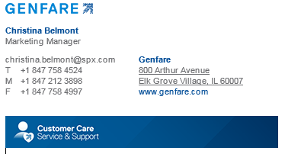

Here is the updated signature to copy and paste, please edit your information accordingly:

**STANDARD SIGNATURE – Copy below:**

|  |
| --- |
| [Genfare logo](http://www.genfare.com/) |
|  |
| **Firstname Lastname** Job Title |
|  |
| |  |  |  |  |  |  |  |  |  |  | | --- | --- | --- | --- | --- | --- | --- | --- | --- | --- | | |  |  |  |  |  |  |  | | --- | --- | --- | --- | --- | --- | --- | | email.address@spx.com   |  |  | | --- | --- | | T | +1 847 000 0000 | | M | +1 847 000 0000 | | F | +1 847 000 0000 | | | |  | | --- | | **Genfare** 800 Arthur Avenue Elk Grove Village, IL 60007 [www.genfare.com](http://www.genfare.com) | | |
|  |
| [Customer Care Service & Support logo](http://www.genfare.com/customer-care) |

The information contained in this electronic mail transmission is intended by SPX Corporation for the use of the named individual or entity to which it is directed and may contain information that is confidential or privileged. If you have received this electronic mail transmission in error, please delete it from your system without copying or forwarding it, and notify the sender of the error by reply email so that the sender’s address records can be corrected.

(Stop Copy)

If you have any questions or need further assistance, please contact Christina Belmont at christina.belmont@spx.com or directly at 847.758.4524.